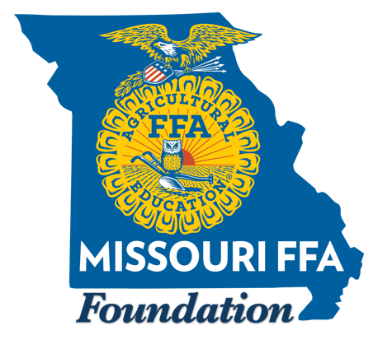
The Missouri FFA Foundation Learning by Doing Grants are designed to help Missouri agriculture education teachers enhance learning opportunities for students. This fall, we have funding for grants up to $1000 for Technology Enhancement projects, supported by Google.org, and grants up to $5,000 for Workforce Development Projects, supported by our Missouri Department of Agriculture Funding.

Important Details & Instructions for 2024 Funding:
- Applications are due by Monday, October 14 at 11:59 p.m. Please email applications to morgan.watkins@missouriffa.org

- When submitting the application, please rename the document to include your FFA Chapter’s name.

- Proposals for Technology Enhancement funding may include requests for the purchase of new or update of existing technology to be used in agriculture education instruction. Ten grants of up to $1000 each will be awarded.

- Workforce Development Project proposals must address at least one need and/or align with at least one strategy outlined in the 2020 study entitled Workforce Needs Assessment of Missouri’s Food, Agriculture and Forestry Industries which can be found at: https://extension.missouri.edu/media/wysiwyg/Extensiondata/Int/BusinessAndCommunity/Docs/WorkforceNeedsAssess-ExecSummary.pdf. Seventeen grants of up to $5000 each are available.

- While local matching funds are not required, local support, either as matching funds, community volunteer support, a community partnership, etc. are more likely to receive a higher score. (Please refer to the scoring rubric for more information.)

- There is no minimum or maximum word or character count required for the proposal answers. The scoring rubric will be valuable in answering questions about specifics to include in the proposal. You may also email Morgan Watkins, Missouri FFA Foundation Intern, at morgan@missouriffa.org with additional questions.

- The Statement of Understanding must be included with your application.

- Only one Learning by Doing application per school district may be submitted each year. Preference for these grants will be given to those schools who have not already had a Horizon or Rising Sun Grant in 2024.

- Award notifications will happen on or before November 11.

- A report of project results, including a financial report of all income and expenses, and at least five project photos, must be submitted by March 10, 2025. The report form will be sent out with award notifications.
School Name & FFA Chapter:

FFA Area:

Ag Ed/FFA District:

Teacher First and Last Name:

Teacher Email Address:

Teacher School Phone Number:

Teacher Alternate Phone Number (i.e. Mobile or Home Phone Number):

Technology Enhancement Grants (maximum request $1000)
Workforce Enhancement Grants (maximum request $5000)

Project Title:

Project Details
- Describe the proposed project in detail. (Include the issue you hope to address with the project, why this particular solution was chosen over another, the desired impact on student learning, if there will be any impact on the community, plans for sustainability or ending the project, etc.)

- What are two measurable student learning goals you have for the project? How will you evaluate if this learning has occurred?

- How many students will be impacted by the project per year? How many years will the impact occur?

- Is there local support for the project? If so, please describe it. (This may include matching funds, volunteer support, community partnership, etc.)

Financial Details
- Please provide a detailed budget for the project.
Item Type | Description | Total Cost

- Why are grant funds needed for this project?

- What is the total amount you are requesting from the Missouri FFA Foundation?

- How do you plan to fund project costs not covered by the Missouri FFA Foundation grant? (If you have already secured additional sources of funding, please list them.)

Technology in Agriculture Philosophy (Only required for Technology Enhancement Grants)
- Describe the impact you believe technology will have on the future of agriculture.

- How does your proposed project fit into this future?

Workforce Development Connection (Only required for Workforce Development Grants)
- How does the project align with the needs and/or strategies outlined in the 2020 report entitled Workforce Needs Assessment of Missouri’s Food, Agriculture and Forestry Industries?

- Do you have a signed letter(s) of recommendation from your agricultural education advisory committee?

Statement of Understanding
If selected for this grant program I agree to the following:
• Funds will be spent as specified in the budget in the timeline specified. (Requests to amend the budget or scope of the project must be submitted in writing to the Missouri FFA Foundation and approved before changes are made.)

• I will submit a written impact report and photos of the project to the Missouri FFA Foundation.

• I understand that if funds are not spent according to the grant application that my school will be expected to return the entire amount of the grant to the Missouri FFA Foundation.

• I have prepared this application and certify that the records are complete and accurate; and I hereby permit the use of any information included in this application for publicity and/or for donor/sponsor updates.

Teacher Initials/Signature: Date:
(By typing your initials or signing your name you are agreeing to the conditions in the Statement of Understanding)

Principal Initials/Signature: Date:
(By typing your initials or signing your name you are agreeing to the conditions in the Statement of Understanding)

