September 20, 2024

Dear Missouri Agriculture Education Teachers,

The Missouri FFA Foundation is pleased to announce we’re opening the application process for the Learning by Doing Classroom Grants for this fall! Currently, we will be accepting proposals for Technology Enhancement Grants and Workforce Development Project Grants.

Technology Enhancement Grants

Teachers can apply for up to $1000 in funds for the purchase of new or update of existing technology to be used in agriculture education instruction. Almost any type of technology is eligible for funding. Some examples would include but are not limited to ultrasound machines for livestock production, energy efficient climate controls for greenhouses, 3-D printers for making hard to find/fit parts in ag mechanics classes, and drones for crop production. These grants are supported through the generosity of Google.org. With this funding, ten grants of up to $1000 each will be awarded.

Workforce Development Project Grants

Teachers can apply for up to $5000 in funds for the purchase of new or update of existing equipment, curriculum, or supplies to be used to enhance workforce development instruction in the agriculture education classroom. These grants are supported through funding the foundation has received from the Missouri Department of Agriculture. With this funding, seventeen grants of up to $5000 each will be awarded. Preference for these grants will be given to those schools who have not already had a Horizon or Rising Sun Grant in 2024.

Applications are due October 14. For more information or to apply, please review the application and scoring rubric attached with this letter.

If you have any questions that aren’t answered by the application instructions or the scoring rubric, please feel free to contact Morgan Watkins, Missouri FFA Foundation Intern, at morgan.watkins@missouriffa.org,

Sincerely,

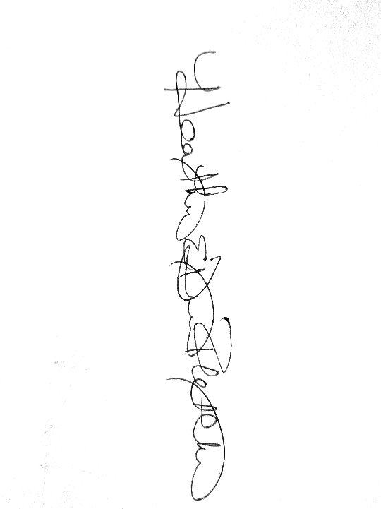

Heather Dimitt-Fletcher

Missouri FFA Foundation Executive Director