April 10, 20215

Dear Missouri Agriculture Education Teachers,

The Missouri FFA Foundation is pleased to announce the availability of funds for the Horizon and Rising Sun Grant program. These grants are intended to assist Missouri high school agriculture education programs prepare the workforce to meet the future needs of the Missouri agriculture industry. Grant awards for these programs range from $10,000-$50,000.

The Horizon Grants support updates or improvements needed for existing high school agriculture education programming. Schools may ask for $10,000-$20,000 in funding for projects that will enhance, replace, or expand existing facilities, equipment, lab supplies, curriculum, etc. The Horizon Grant requests should include at least a 50% local match.

The Rising Sun Grants support the launch of new high school agriculture education programs or new to the school agriculture education programming/classes. Schools may ask for $25,000-$50,000 in funding for facilities, equipment, lab supplies, curriculum, etc. A 25% local match is required.

The 2025 Horizon and Rising Sun Grants have been made possible due to generous support from the State of Missouri and the Missouri Department of Agriculture.

Proposed projects for both grant programs should address at least one need and/or align with the strategies outlined in the 2020 study entitled Workforce Needs Assessment of Missouri’s Food, Agriculture and Forestry Industries.

Applications are due May 30, 2025. For more information or to apply, please review the application, scoring rubric, and budget template attached with this letter.

A technical assistance webinar will be held on May 7 for these grants. Details regarding the webinar are in the application and Q&A.

Sincerely,

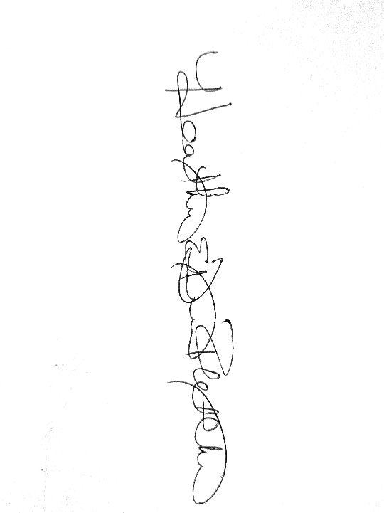

Heather Dimitt-Fletcher

Missouri FFA Foundation Executive Director